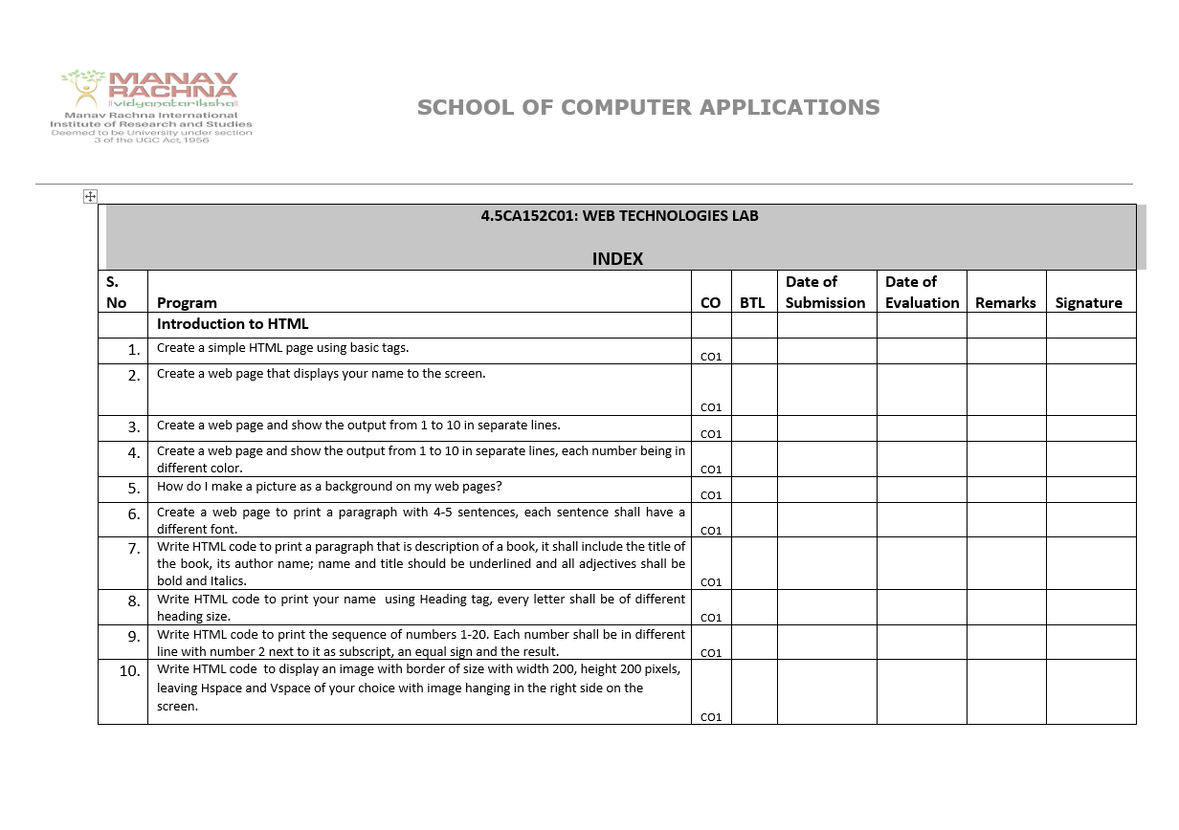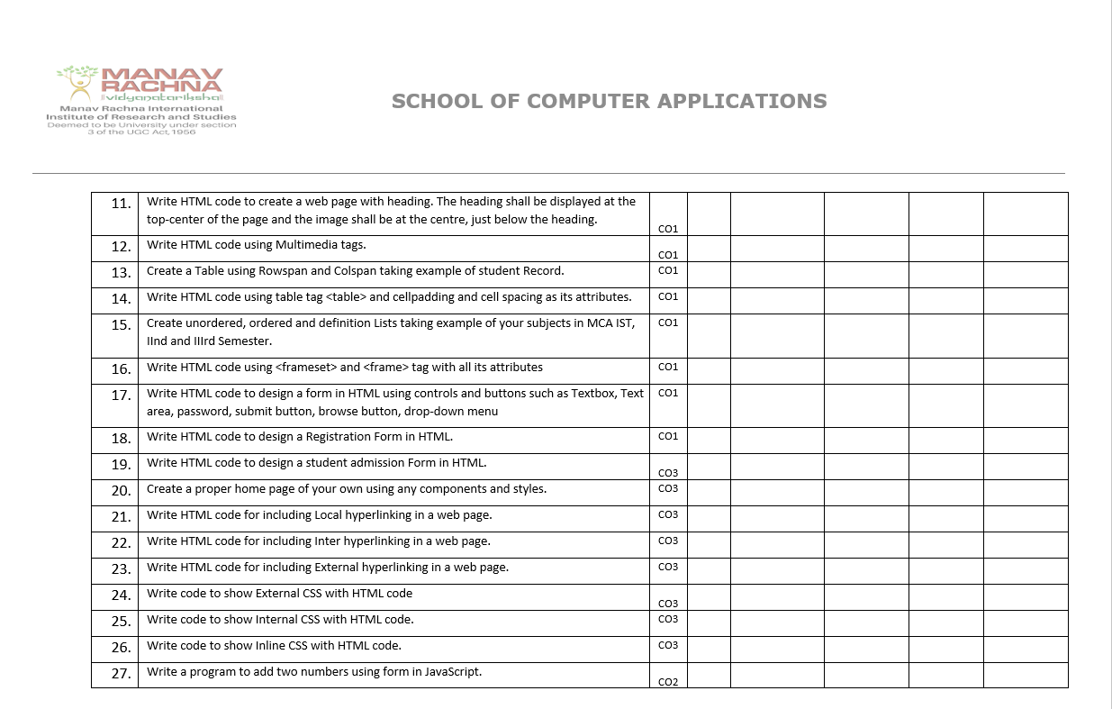

Roll no – 24/SCA/BCA/047

Full name – Shubh Mittal

Department – SCA(school of computer application)

Program name – BCA

Section - A







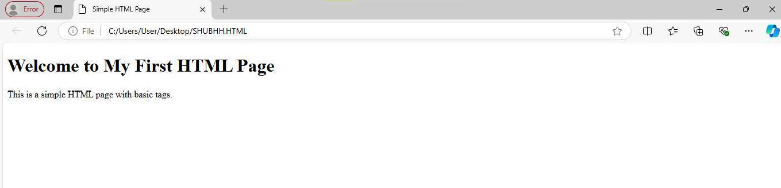









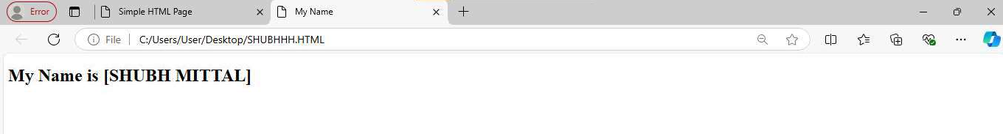











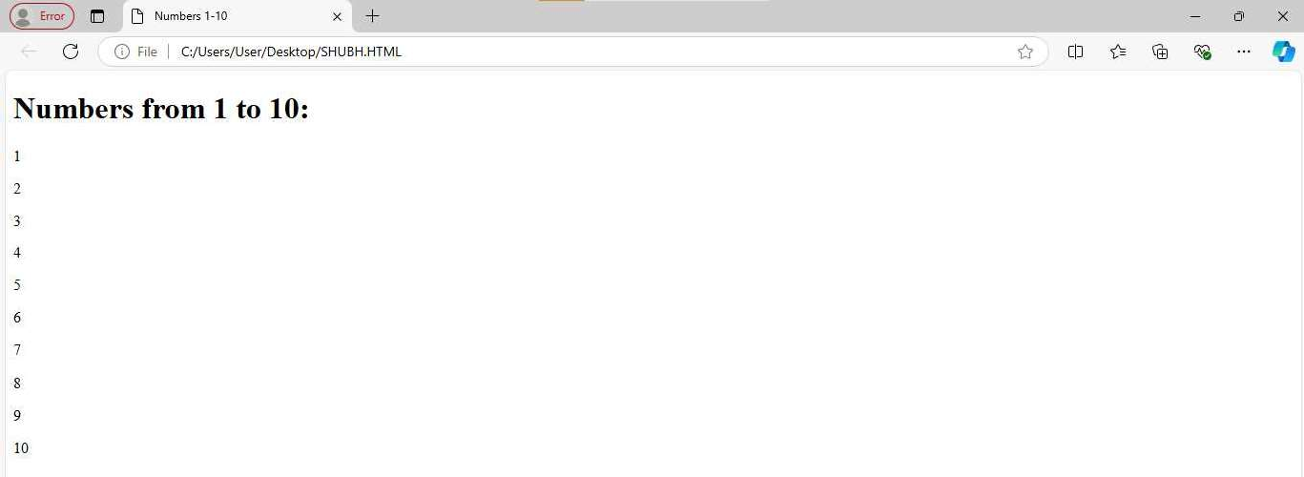





 







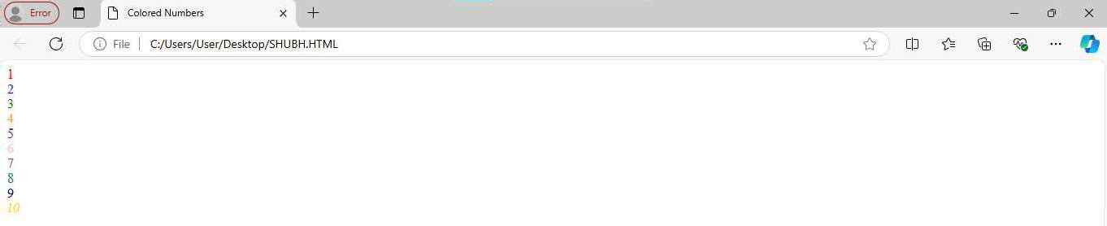







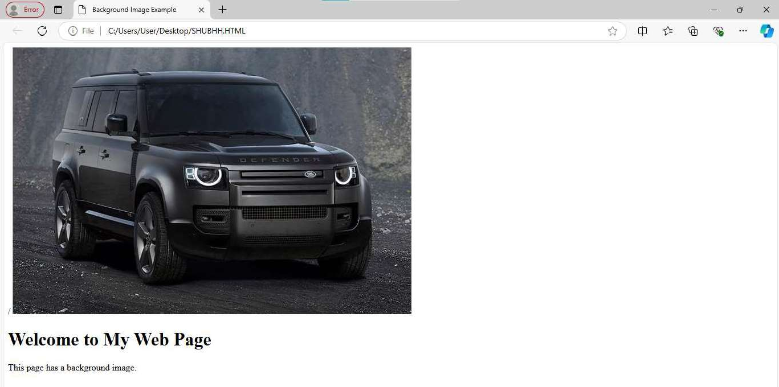



















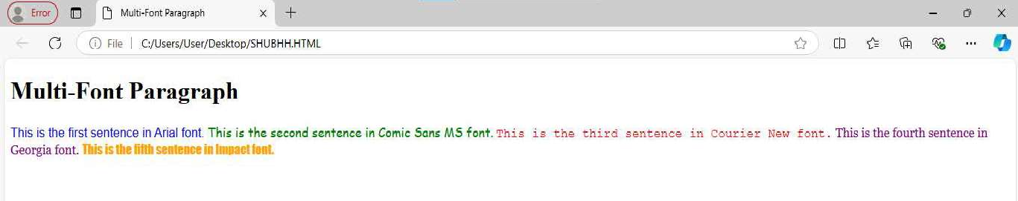

















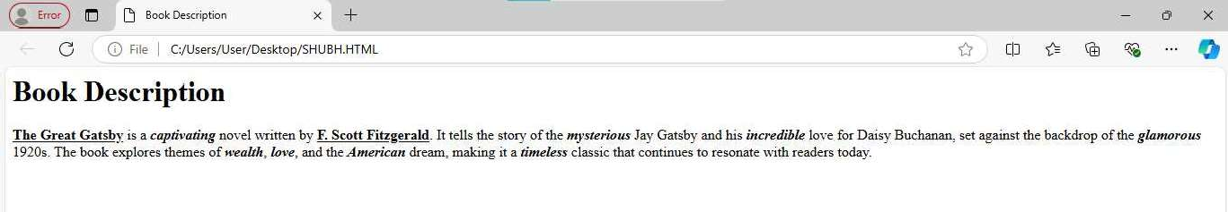



















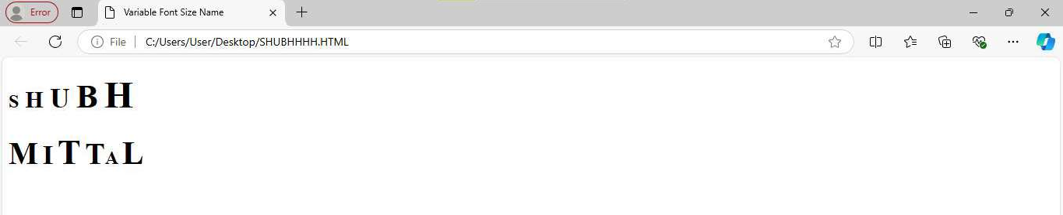





















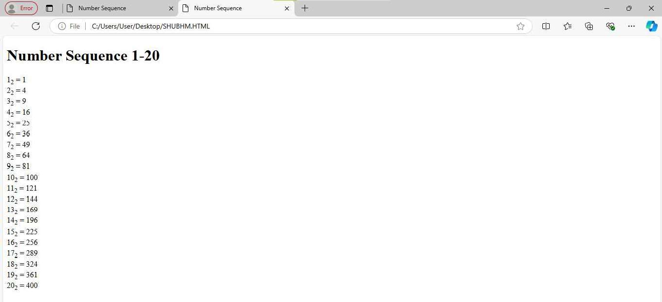















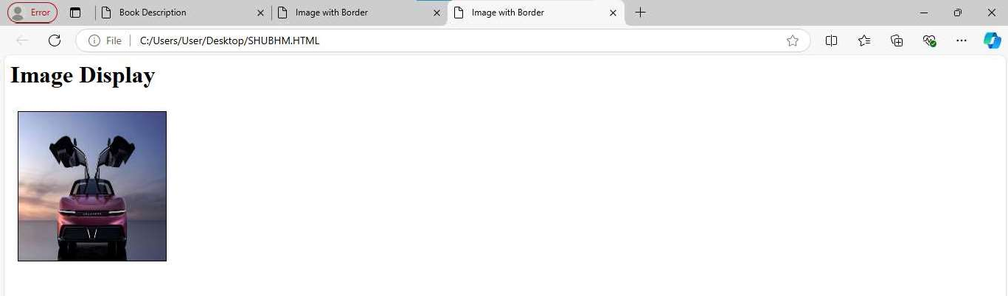

**EXERCISE NO.11**

**QUES-11 WRITE HTML CODE TO CREATE A WEB PAGE WITH HEADING. THE HEADING SHALL BE DISPLAYED AT THE TOP-CENTER OF THR PAGE AND THE IMAGE SHALL AT THE CENTRE,JUST BELO THE HEADING?**

**CODE:**

<!DOCTYPE html>

<html>

<head>

<title>Centered Heading and Image</title>

<style>

body {

margin: 0;

padding: 0;

background-color: #f2f2f2;

}

.container {

text-align: center;

padding-top: 50px;

}

.image-container {

margin-top: 50px;

}

.image-container img {

width: 50%;

height: auto;

border-radius: 10px;

box-shadow: 0 0 10px rgba(0, 0, 0, 0.2);

}

</style>

</head>

<body>

<div class="container">

<h1>Centered Heading</h1>

<div class="image-container">

<img src="C:\Users\User\Downloads\WhatsApp Image 2024-10-20 at 10.25.43 AM.jpeg" alt="Centered Image">

</div>

</div>

</body>

</html>

**OUTPUT:**



**EXERCISE NO.12**

QUES-12 WRITE HTML CODE USING MULTIMEDIA TAGS?

**CODE:**

**<!DOCTYPE html>**

**<html>**

**<head>**

**<title>Multimedia Tags</title>**

**<style>**

**body {**

**font-family: Arial, sans-serif;**

**}**

**</style>**

**</head>**

**<body>**

**<h1>Multimedia Tags</h1>**

**<!-- Audio Tag -->**

**<h2>Audio</h2>**

**<audio controls>**

**<source src="audio.mp3" type="audio/mp3">**

**Your browser does not support the audio tag.**

**</audio>**

**<!-- Video Tag -->**

**<h2>Video</h2>**

**<video width="500" height="300" controls>**

**<source src="video.mp4" type="video/mp4">**

**Your browser does not support the video tag.**

**</video>**

**<!-- Image Tag -->**

**<h2>Image</h2>**

**<img src="image.jpg" alt="Multimedia Image" width="500" height="300">**

**<!-- Embed Tag (for YouTube video) -->**

**<h2>Embedded YouTube Video</h2>**

**<embed src="(link unavailable)" width="500" height="300">**

**<!-- Object Tag (for Flash content) -->**

**<h2>Flash Content</h2>**

**<object data="flash.swf" width="500" height="300">**

**<param name="movie" value="flash.swf">**

**Your browser does not support Flash.**

**</object>**

**</body>**

**</html>**

**OUTPUT:**



**EXERCISE NO.13**

**QUES-13 CREATE A TABLE USING COLSPAN AND ROWSPAN TAKING EXAMPLE OF STUDENT RECORD?**

**CODE:**

**<!DOCTYPE html>**

**<html>**

**<head>**

**<title>Student Records</title>**

**<style>**

**table {**

**border-collapse: collapse;**

**}**

**th, td {**

**border: 1px solid #ddd;**

**padding: 10px;**

**text-align: center;**

**}**

**th {**

**background-color: #f0f0f0;**

**}**

**</style>**

**</head>**

**<body>**

**<h1>Student Records</h1>**

**<table>**

**<tr>**

**<th colspan="5">Student Information</th>**

**</tr>**

**<tr>**

**<th>Student ID</th>**

**<th>Name</th>**

**<th>Grade</th>**

**<th>Subjects</th>**

**<th>Average Score</th>**

**</tr>**

**<tr>**

**<td>001</td>**

**<td>John Doe</td>**

**<td>10th</td>**

**<td rowspan="3">**

**English<br>**

**Mathematics<br>**

**Science**

**</td>**

**<td>85%</td>**

**</tr>**

**<tr>**

**<td>002</td>**

**<td>Jane Smith</td>**

**<td>10th</td>**

**<td>90%</td>**

**</tr>**

**<tr>**

**<td>003</td>**

**<td>Bob Johnson</td>**

**<td>10th</td>**

**<td>88%</td>**

**</tr>**

**<tr>**

**<th colspan="5">Total</th>**

**</tr>**

**<tr>**

**<td colspan="4">Average Score:</td>**

**<td>87.67%</td>**

**</tr>**

**</table>**

**</body>**

**</html>**

**OUTPUT:**



**EXERCISE NO.14**

**QUES-14 WRITE HTML CODE USING TABLE TAG<TABLE> AN CELLPADDING AND CELLSPACING AS ITS ATTRIBUTES?**

**CODE:**

**<!DOCTYPE html>**

**<html>**

**<head>**

**<title>Table Example</title>**

**</head>**

**<body>**

**<h1>Table Example</h1>**

**<table cellpadding="10" cellspacing="5" border="1">**

**<tr>**

**<th>Header 1</th>**

**<th>Header 2</th>**

**<th>Header 3</th>**

**</tr>**

**<tr>**

**<td>Cell 1</td>**

**<td>Cell 2</td>**

**<td>Cell 3</td>**

**</tr>**

**<tr>**

**<td>Cell 4</td>**

**<td>Cell 5</td>**

**<td>Cell 6</td>**

**</tr>**

**</table>**

**</body>**

**</html>**

**OUTPUT:**



**EXERCISE NO.15**

**QUES-15 CREATE ORDERED, UNORDERED AND DEFINATION LISTS TAKING EXAMPLE OF YOUR SUBJECTS IN MCA IST, ||ND AND |||SEMSESTER?**

**CODE:**

**<!DOCTYPE html>**

**<html>**

**<head>**

**<title>MCA Subjects</title>**

**</head>**

**<body>**

**<h1>MCA 1st Semester (Ordered List)</h1>**

**<ol>**

**<li>Programming Fundamentals (PF)</li>**

**<li>Data Structures (DS)</li>**

**<li>Computer Organization (CO)</li>**

**<li>Discrete Mathematics (DM)</li>**

**<li>Software Engineering (SE)</li>**

**<li>Web Technologies (WT)</li>**

**</ol>**

**<h1>MCA 2nd Semester (Unordered List)</h1>**

**<ul>**

**<li>Object-Oriented Programming (OOP)</li>**

**<li>Database Management Systems (DBMS)</li>**

**<li>Operating Systems (OS)</li>**

**<li>Computer Networks (CN)</li>**

**<li>Cyber Security (CS)</li>**

**<li>Data Mining (DM)</li>**

**</ul>**

**<h1>MCA 3rd Semester (Definition List)</h1>**

**<dl>**

**<dt>Elective Subjects:</dt>**

**<dd>Artificial Intelligence (AI): Study of intelligent agents and their applications.</dd>**

**<dd>Machine Learning (ML): Study of algorithms that enable machines to learn from data.</dd>**

**<dd>Data Analytics (DA): Study of methods for extracting insights from data.</dd>**

**<dt>Core Subjects:</dt>**

**<dd>Advanced Computer Architecture (ACA): Study of advanced computer architecture concepts.</dd>**

**<dd>Human-Computer Interaction (HCI): Study of interaction between humans and computers.</dd>**

**</dl>**

**</body>**

**</html>**

**OUTPUT:**



**EXERCISE NO.16**

**QUES-16 WRITE HTML CODE USING <FRAMESET> AND <FRAME> TAG WITH ALL ITS ATTRIBUTES?**

**CODE:**

**<!DOCTYPE html>**

**<html>**

**<head>**

**<title>Frameset Example</title>**

**</head>**

**<frameset rows="20%, 80%">**

**<frame src="header.html" name="header" frameborder="0" scrolling="no" noresize>**

**<frameset cols="30%, 70%">**

**<frame src="menu.html" name="menu" frameborder="0" scrolling="auto">**

**<frame src="content.html" name="content" frameborder="0" scrolling="auto">**

**</frameset>**

**</frameset>**

**</html>**

**OUTPUT:**



**EXERCISE NO.17**

**QUES-17 WRITE HTML CODE TO DESIGN A FORM IN HTML USING CONTROLS AND BUTTONS SUCH AS TEXTBOX, TEXT AREA, PASSWORD, SUBMIT BUTTON, BROWSE BUTTON, DROP-DOWN MENU?**

**CODE:**

**<!DOCTYPE html>**

**<html>**

**<head>**

**<title>Registration Form</title>**

**<style>**

**body {**

**font-family: Arial, sans-serif;**

**}**

**form {**

**width: 50%;**

**margin: 40px auto;**

**padding: 20px;**

**border: 1px solid #ccc;**

**border-radius: 10px;**

**box-shadow: 0 0 10px rgba(0, 0, 0, 0.1);**

**}**

**label {**

**display: block;**

**margin-bottom: 10px;**

**}**

**input[type="text"], input[type="password"], select {**

**width: 100%;**

**height: 40px;**

**margin-bottom: 20px;**

**padding: 10px;**

**border: 1px solid #ccc;**

**}**

**textarea {**

**width: 100%;**

**height: 100px;**

**margin-bottom: 20px;**

**padding: 10px;**

**border: 1px solid #ccc;**

**}**

**input[type="submit"], input[type="reset"] {**

**width: 100%;**

**height: 40px;**

**background-color: #4CAF50;**

**color: #fff;**

**padding: 10px;**

**border: none;**

**border-radius: 5px;**

**cursor: pointer;**

**}**

**input[type="submit"]:hover, input[type="reset"]:hover {**

**background-color: #3e8e41;**

**}**

**</style>**

**</head>**

**<body>**

**<h1>Registration Form</h1>**

**<form>**

**<label for="name">Name:</label>**

**<input type="text" id="name" placeholder="Enter your name">**

**<label for="email">Email:</label>**

**<input type="text" id="email" placeholder="Enter your email">**

**<label for="password">Password:</label>**

**<input type="password" id="password" placeholder="Enter your password">**

**<label for="address">Address:</label>**

**<textarea id="address" placeholder="Enter your address"></textarea>**

**<label for="country">Country:</label>**

**<select id="country">**

**<option value="">Select your country</option>**

**<option value="USA">USA</option>**

**<option value="Canada">Canada</option>**

**<option value="UK">UK</option>**

**</select>**

**<label for="profile">Profile Picture:</label>**

**<input type="file" id="profile">**

**<input type="submit" value="Register">**

**<input type="reset" value="Reset">**

**</form>**

**</body>**

**</html>**

**OUTPUT:**



**EXERCISE NO.18**

**QUES-18 WRITE HTML CODE TO DESIGN A REGISTRATION FORM IN HTML?**

**CODE:**

**<!DOCTYPE html>**

**<html>**

**<head>**

**<title>Registration Form</title>**

**<style>**

**body {**

**font-family: Arial, sans-serif;**

**background-color: #f2f2f2;**

**}**

**.form-container {**

**width: 300px;**

**margin: 50px auto;**

**padding: 20px;**

**background-color: #fff;**

**border: 1px solid #ddd;**

**border-radius: 10px;**

**box-shadow: 0 0 10px rgba(0, 0, 0, 0.1);**

**}**

**.form-title {**

**text-align: center;**

**margin-bottom: 20px;**

**}**

**.form-label {**

**display: block;**

**margin-bottom: 10px;**

**}**

**.form-input {**

**width: 100%;**

**height: 40px;**

**margin-bottom: 20px;**

**padding: 10px;**

**border: 1px solid #ccc;**

**}**

**.form-button {**

**width: 100%;**

**height: 40px;**

**background-color: #4CAF50;**

**color: #fff;**

**padding: 10px;**

**border: none;**

**border-radius: 5px;**

**cursor: pointer;**

**}**

**.form-button:hover {**

**background-color: #3e8e41;**

**}**

**</style>**

**</head>**

**<body>**

**<div class="form-container">**

**<h2 class="form-title">Registration Form</h2>**

**<form>**

**<label class="form-label" for="fname">First Name:</label>**

**<input class="form-input" type="text" id="fname" placeholder="Enter first name">**

**<label class="form-label" for="lname">Last Name:</label>**

**<input class="form-input" type="text" id="lname" placeholder="Enter last name">**

**<label class="form-label" for="email">Email:</label>**

**<input class="form-input" type="email" id="email" placeholder="Enter email">**

**<label class="form-label" for="password">Password:</label>**

**<input class="form-input" type="password" id="password" placeholder="Enter password">**

**<label class="form-label" for="confirm-password">Confirm Password:</label>**

**<input class="form-input" type="password" id="confirm-password" placeholder="Enter confirm password">**

**<label class="form-label" for="phone">Phone Number:</label>**

**<input class="form-input" type="tel" id="phone" placeholder="Enter phone number">**

**<label class="form-label" for="address">Address:</label>**

**<textarea class="form-input" id="address" placeholder="Enter address"></textarea>**

**<input class="form-button" type="submit" value="Register">**

**</form>**

**</div>**

**</body>**

**</html>**

**OUTPUT:**



**EXERCISE N0.19**

QUES-19 WRITE HTML CODE TO DESIGN A STUDENT ADMISSION FORM IN HTML?

**CODE:**

**Here's an example HTML code to design a student admission form:**

**<!DOCTYPE html>**

**<html>**

**<head>**

**<title>Student Admission Form</title>**

**<style>**

**body {**

**font-family: Arial, sans-serif;**

**background-color: #f2f2f2;**

**}**

**.form-container {**

**width: 600px;**

**margin: 50px auto;**

**padding: 20px;**

**background-color: #fff;**

**border: 1px solid #ddd;**

**border-radius: 10px;**

**box-shadow: 0 0 10px rgba(0, 0, 0, 0.1);**

**}**

**.form-title {**

**text-align: center;**

**margin-bottom: 20px;**

**}**

**.form-label {**

**display: block;**

**margin-bottom: 10px;**

**}**

**.form-input {**

**width: 100%;**

**height: 40px;**

**margin-bottom: 20px;**

**padding: 10px;**

**border: 1px solid #ccc;**

**}**

**.form-button {**

**width: 100%;**

**height: 40px;**

**background-color: #4CAF50;**

**color: #fff;**

**padding: 10px;**

**border: none;**

**border-radius: 5px;**

**cursor: pointer;**

**}**

**.form-button:hover {**

**background-color: #3e8e41;**

**}**

**</style>**

**</head>**

**<body>**

**<div class="form-container">**

**<h2 class="form-title">Student Admission Form</h2>**

**<form>**

**<!-- Student Information -->**

**<h3>Student Information:</h3>**

**<label class="form-label" for="name">Name:</label>**

**<input class="form-input" type="text" id="name" placeholder="Enter name">**

**<label class="form-label" for="dateOfBirth">Date of Birth:</label>**

**<input class="form-input" type="date" id="dateOfBirth" placeholder="Enter date of birth">**

**<label class="form-label" for="gender">Gender:</label>**

**<select class="form-input" id="gender">**

**<option value="">Select gender</option>**

**<option value="male">Male</option>**

**<option value="female">Female</option>**

**<option value="other">Other</option>**

**</select>**

**<!-- Parent Information -->**

**<h3>Parent Information:</h3>**

**<label class="form-label" for="fatherName">Father's Name:</label>**

**<input class="form-input" type="text" id="fatherName" placeholder="Enter father's name">**

**<label class="form-label" for="motherName">Mother's Name:</label>**

**<input class="form-input" type="text" id="motherName" placeholder="Enter mother's name">**

**<label class="form-label" for="parentContact">Parent Contact:</label>**

**<input class="form-input" type="tel" id="parentContact" placeholder="Enter parent contact">**

**<!-- Educational Information -->**

**<h3>Educational Information:</h3>**

**<label class="form-label" for="course">Course:</label>**

**<select class="form-input" id="course">**

**<option value="">Select course</option>**

**<option value="BCA">BCA</option>**

**<option value="B.Tech">B.Tech</option>**

**<option value="MCA">MCA</option>**

**<option value="M.Tech">M.Tech</option>**

**</select>**

**<label class="form-label" for="semester">Semester:</label>**

**<select class="form-input" id="semester">**

**<option value="">Select semester</option>**

**<option value="1st">1st</option>**

**<option value="2nd">2nd</option>**

**<option value="3rd">3rd</option>**

**<option value="4th">4th</option>**

**<option value="5th">5th</option>**

**<option value="6th">6th</option>**

**</select>**

**<!-- Address -->**

**<h3>Address:</h3>**

**<label class="form-label" for="address">Address:</label>**

**<textarea class="form-input" id="address" placeholder="Enter address"></textarea>**

**<!-- Submit Button -->**

**<input class="form-button" type="submit" value="Submit">**

**</form>**

**</div>**

**</body>**

**</html>**

**OUTPUT:**



**EXERCISE N0.20**

Create a proper home page of your own using any components and styles.

<!DOCTYPE html>

<html lang="en">

<head>

<meta charset="UTF-8">

<meta name="viewport" content="width=device-width, initial-scale=1.0">

<title>Meta AI Home</title>

<link rel="stylesheet" href="styles.css">

</head>

<body>

<!-- Header Section -->

<header>

<nav>

<ul>

<li><a href="#home">Home</a></li>

<li><a href="#about">About</a></li>

<li><a href="#contact">Contact</a></li>

</ul>

</nav>

</header>

<!-- Hero Section -->

<section id="home">

<h1>Welcome to Meta AI Home</h1>

<p>Explore the world of AI and beyond!</p>

<button>Learn More</button>

</section>

<!-- About Section -->

<section id="about">

<h2>About Us</h2>

<p>We're passionate about AI and its applications.</p>

<img src="ai-image.jpg" alt="AI Image">

</section>

<!-- Contact Section -->

<section id="contact">

<h2>Get in Touch</h2>

<form>

<input type="text" placeholder="Name">

<input type="email" placeholder="Email">

<textarea placeholder="Message"></textarea>

<button>Send</button>

</form>

</section>

<!-- Footer Section -->

<footer>

<p>&copy; 2024 Meta AI Home</p>

</footer>

<script src="script.js"></script>

</body>

</html>

styles.css

body {

font-family: Arial, sans-serif;

margin: 0;

padding: 0;

}

header {

background-color: #333;

color: #fff;

padding: 1em;

text-align: center;

}

nav ul {

list-style: none;

margin: 0;

padding: 0;

display: flex;

justify-content: space-between;

}

nav li {

margin-right: 20px;

}

nav a {

color: #fff;

text-decoration: none;

}

#home {

background-image: linear-gradient(to bottom, #f7f7f7, #fff);

padding: 5em;

text-align: center;

}

#about {

background-color: #f7f7f7;

padding: 3em;

}

#about img {

width: 50%;

height: auto;

margin: 20px auto;

}

#contact {

background-color: #fff;

padding: 3em;

}

form {

display: flex;

flex-direction: column;

align-items: center;

}

input, textarea {

width: 100%;

padding: 10px;

margin-bottom: 20px;

border: 1px solid #ccc;

}

button {

background-color: #333;

color: #fff;

border: none;

padding: 10px 20px;

cursor: pointer;

}

footer {

background-color: #333;

color: #fff;

padding: 1em;

text-align: center;

clear: both;

}

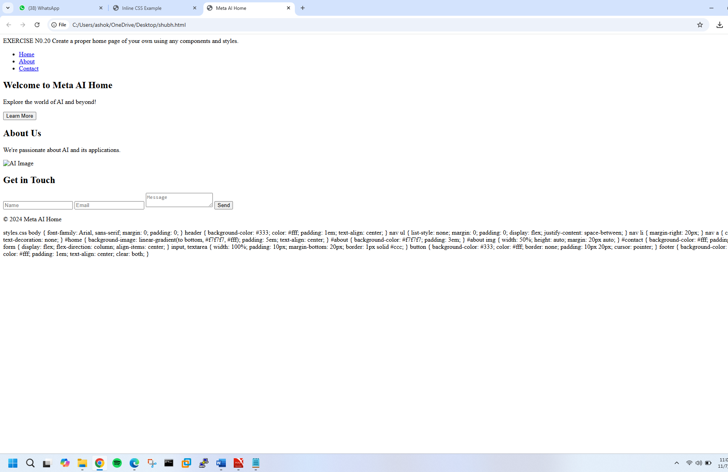

**EXERCISE N0.21**

Write HTML code for including Local hyperlinking in a web page.

<!DOCTYPE html>

<html>

<head>

<title>Local Hyperlinking Example</title>

</head>

<body>

<!-- Creating a hyperlink to a section within the same page -->

<a href="#top">Go to Top</a> |

<a href="#middle">Go to Middle</a> |

<a href="#bottom">Go to Bottom</a>

<!-- Content -->

<p>Lorem ipsum dolor sit amet, consectetur adipiscing elit. Sed sit amet nulla auctor, vestibulum magna sed, convallis ex.</p>

<p>Lorem ipsum dolor sit amet, consectetur adipiscing elit. Sed sit amet nulla auctor, vestibulum magna sed, convallis ex.</p>

<!-- Anchor tag with id attribute for "Top" section -->

<h2 id="top">Top Section</h2>

<p>Lorem ipsum dolor sit amet, consectetur adipiscing elit. Sed sit amet nulla auctor, vestibulum magna sed, convallis ex.</p>

<p>Lorem ipsum dolor sit amet, consectetur adipiscing elit. Sed sit amet nulla auctor, vestibulum magna sed, convallis ex.</p>

<!-- More content -->

<p>Lorem ipsum dolor sit amet, consectetur adipiscing elit. Sed sit amet nulla auctor, vestibulum magna sed, convallis ex.</p>

<p>Lorem ipsum dolor sit amet, consectetur adipiscing elit. Sed sit amet nulla auctor, vestibulum magna sed, convallis ex.</p>

<!-- Anchor tag with id attribute for "Middle" section -->

<h2 id="middle">Middle Section</h2>

<p>Lorem ipsum dolor sit amet, consectetur adipiscing elit. Sed sit amet nulla auctor, vestibulum magna sed, convallis ex.</p>

<p>Lorem ipsum dolor sit amet, consectetur adipiscing elit. Sed sit amet nulla auctor, vestibulum magna sed, convallis ex.</p>

<!-- More content -->

<p>Lorem ipsum dolor sit amet, consectetur adipiscing elit. Sed sit amet nulla auctor, vestibulum magna sed, convallis ex.</p>

<p>Lorem ipsum dolor sit amet, consectetur adipiscing elit. Sed sit amet nulla auctor, vestibulum magna sed, convallis ex.</p>

<!-- Anchor tag with id attribute for "Bottom" section -->

<h2 id="bottom">Bottom Section</h2>

<p>Lorem ipsum dolor sit amet, consectetur adipiscing elit. Sed sit amet nulla auctor, vestibulum magna sed, convallis ex.</p>

<p>Lorem ipsum dolor sit amet, consectetur adipiscing elit. Sed sit amet nulla auctor, vestibulum magna sed, convallis ex.</p>

</body>

</html>

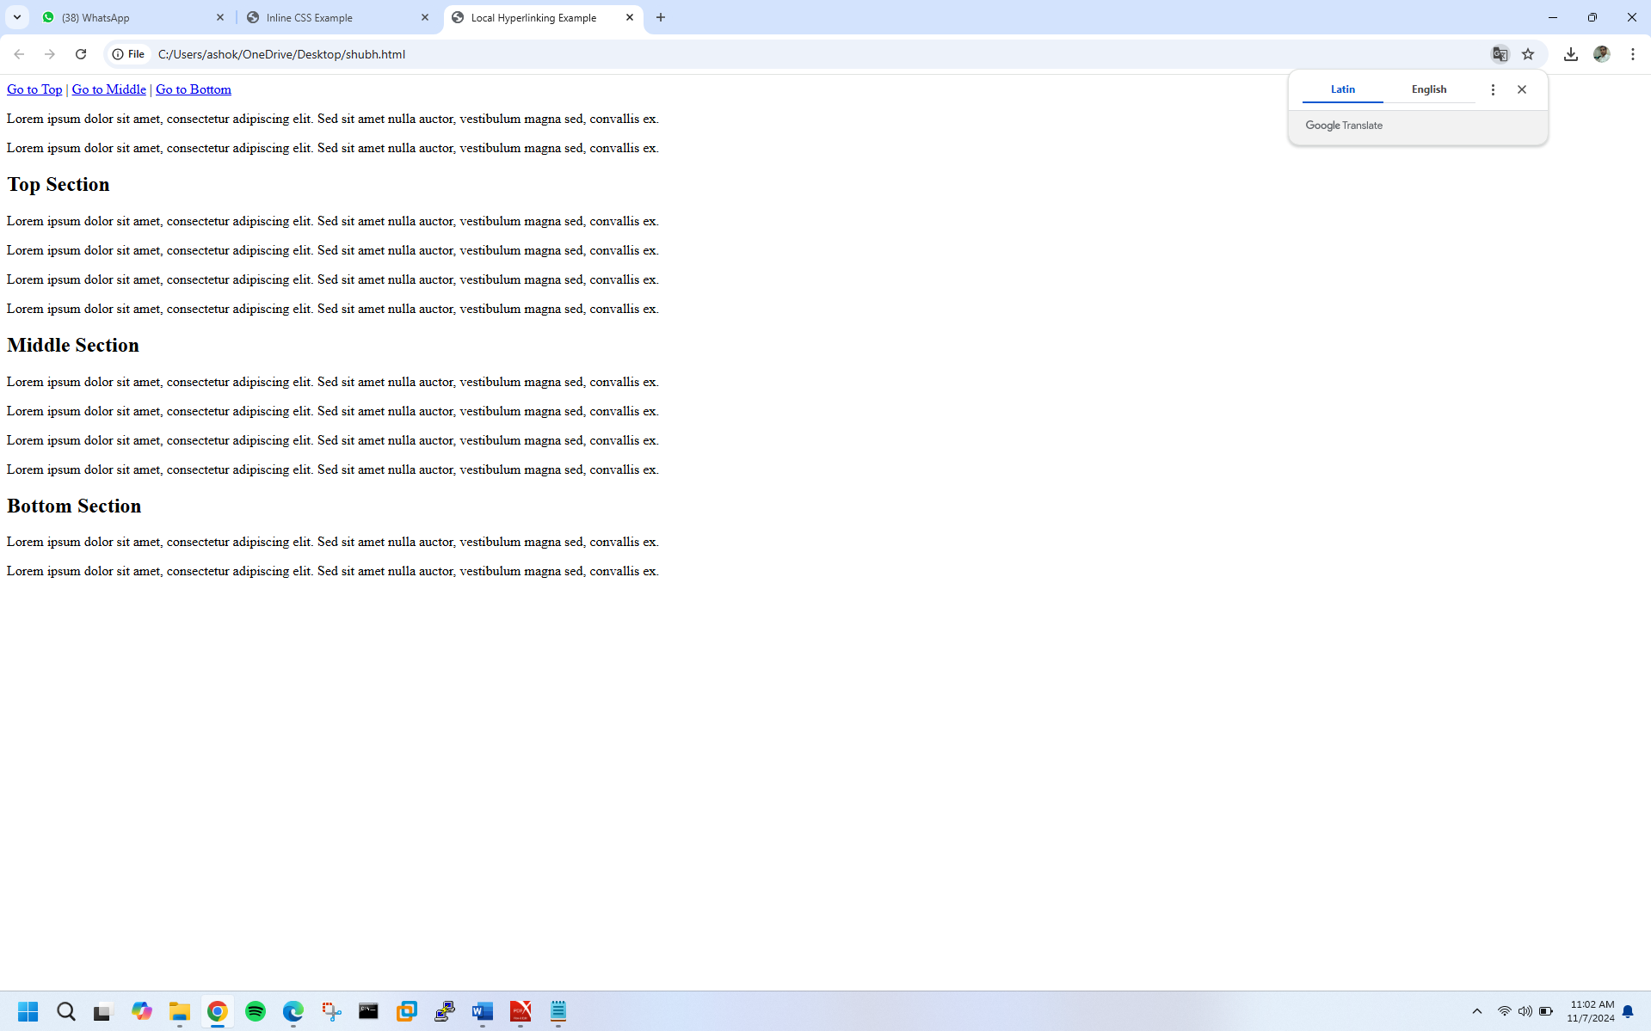

**EXERCISE N0.22**

Write HTML code for including Inter hyperlinking in a web page.

<!DOCTYPE html>

<html>

<head>

<title>Inter Hyperlinking Example</title>

</head>

<body>

<!-- Creating hyperlinks to external web pages -->

<a href="(link unavailable)">Visit Google</a><br>

<a href="(link unavailable)">Visit Facebook</a><br>

<a href="(link unavailable)">Visit Twitter</a><br>

<!-- Target attribute to open link in new tab or window -->

<a href="(link unavailable)" target="_blank">Visit Wikipedia (New Tab)</a><br>

<a href="(link unavailable)" target="_self">Visit GitHub (Same Window)</a><br>

<!-- Title attribute for tooltip text -->

<a href="(link unavailable)" title="Q&A Platform for Developers">Visit Stack Overflow</a><br>

<!-- Email hyperlink -->

<a href="mailto:example@example.com">Email Us</a><br>

</body>

</html>

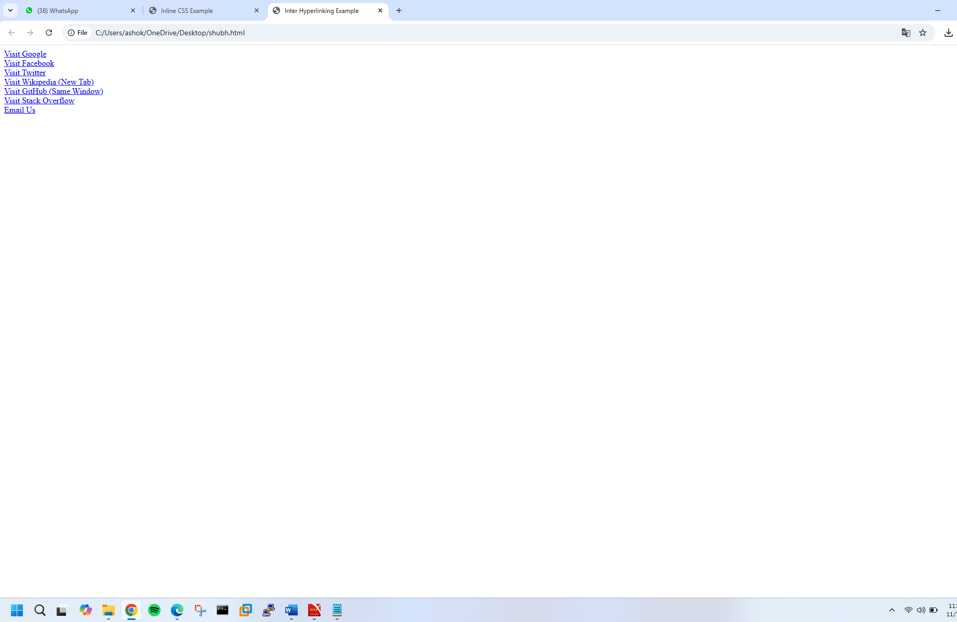

**EXERCISE N0.23**

Write HTML code for including External hyperlinking in a web page.

<!DOCTYPE html>

<html>

<head>

<title>External Hyperlinking Example</title>

</head>

<body>

<!-- External Hyperlink with HTTP protocol -->

<a href="(link unavailable)">Visit Google</a><br>

<!-- External Hyperlink with HTTPS protocol -->

<a href="(link unavailable)">Visit Facebook</a><br>

<!-- External Hyperlink with Target Attribute -->

<a href="(link unavailable)" target="_blank">Visit Twitter (New Tab)</a><br>

<!-- External Hyperlink with Title Attribute -->

<a href="(link unavailable)" title="Free Online Encyclopedia">Visit Wikipedia</a><br>

<!-- External Hyperlink with Image -->

<a href="(link unavailable)"><img src="github-logo.png" alt="GitHub Logo"></a><br>

<!-- External Hyperlink with Email -->

<a href="mailto:info@example.com">Email Us</a><br>

<!-- External Hyperlink with Phone Number -->

<a href="tel:+1234567890">Call Us</a><br>

</body>

</html>

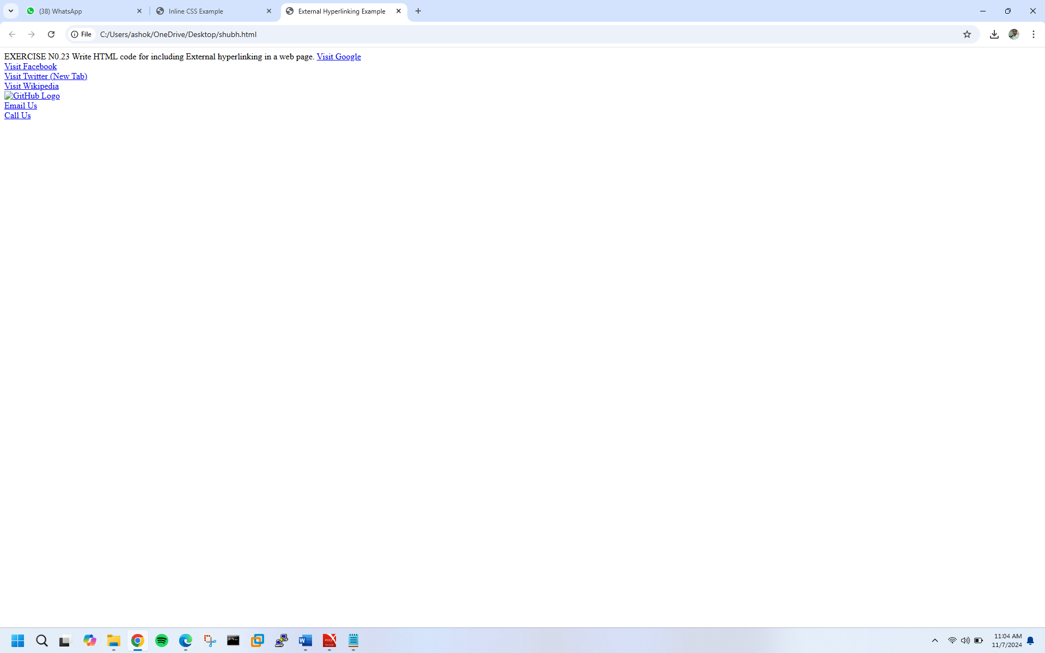

**EXERCISE N0.24**

Write code to show External CSS with HTML code

<!DOCTYPE html>

<html>

<head>

<title>External CSS Example</title>

<link rel="stylesheet" type="text/css" href="styles.css">

</head>

<body>

<h1>Welcome to External CSS Example</h1>

<p>This paragraph will be styled by external CSS.</p>

<a href="(link unavailable)">Visit Google</a>

</body>

</html>

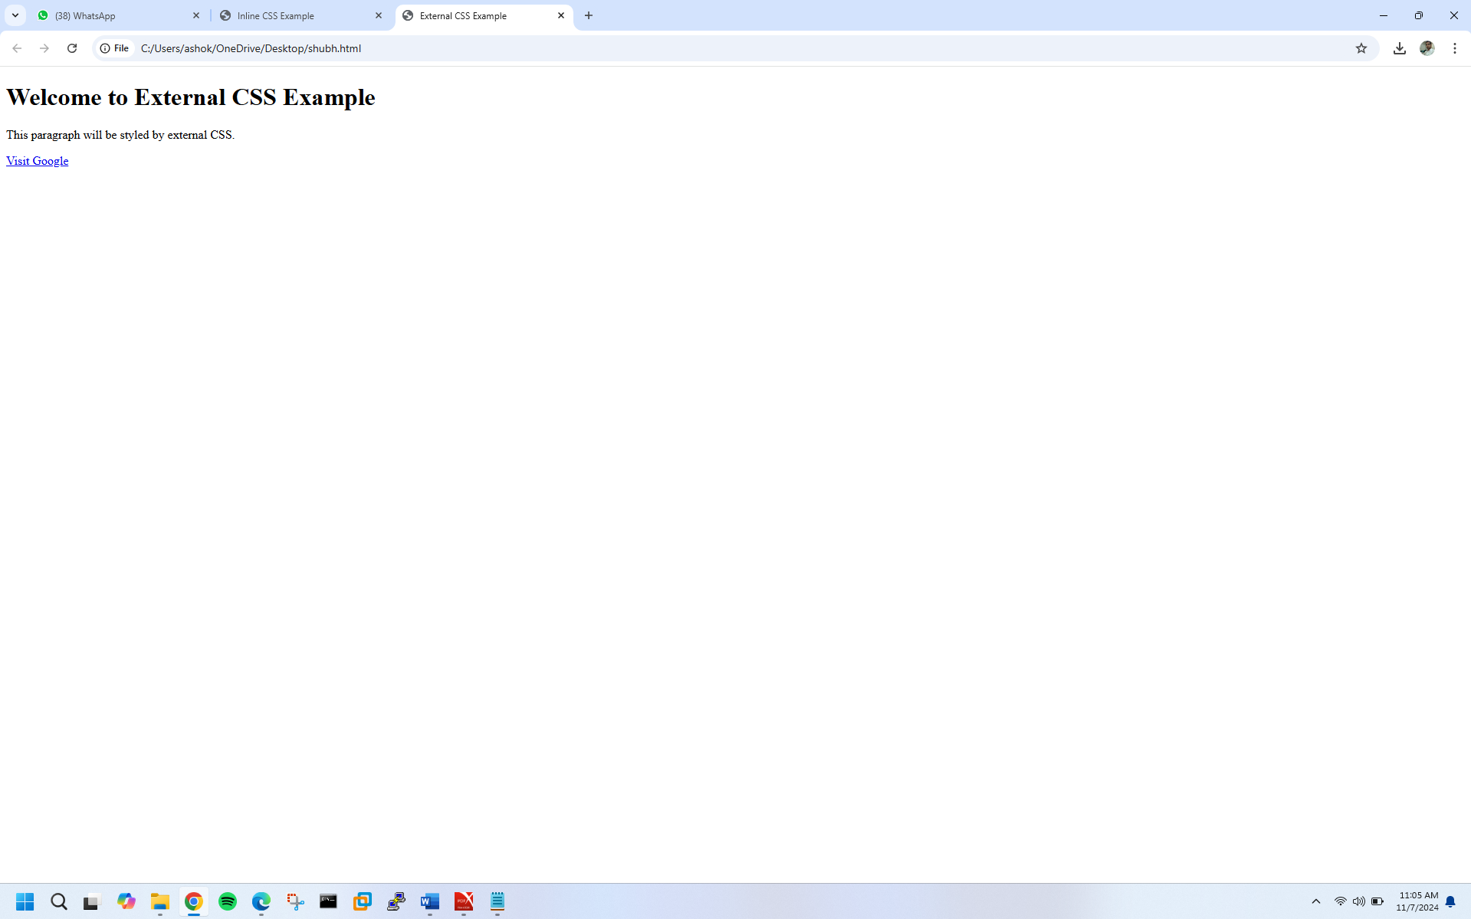

**EXERCISE N0.25**

Write code to show Internal CSS with HTML code.

<!DOCTYPE html>

<html>

<head>

<title>Internal CSS Example</title>

<style>

/* Internal CSS styles */

body {

background-color: #f2f2f2;

font-family: Arial, sans-serif;

}

h1 {

color: #00698f;

text-align: center;

}

p {

font-size: 18px;

color: #666;

margin-bottom: 20px;

}

a {

text-decoration: none;

color: #0096c7;

}

a:hover {

color: #007bff;

}

</style>

</head>

<body>

<h1>Welcome to Internal CSS Example</h1>

<p>This paragraph will be styled by internal CSS.</p>

<a href="(link unavailable)">Visit Google</a>

</body>

</html>

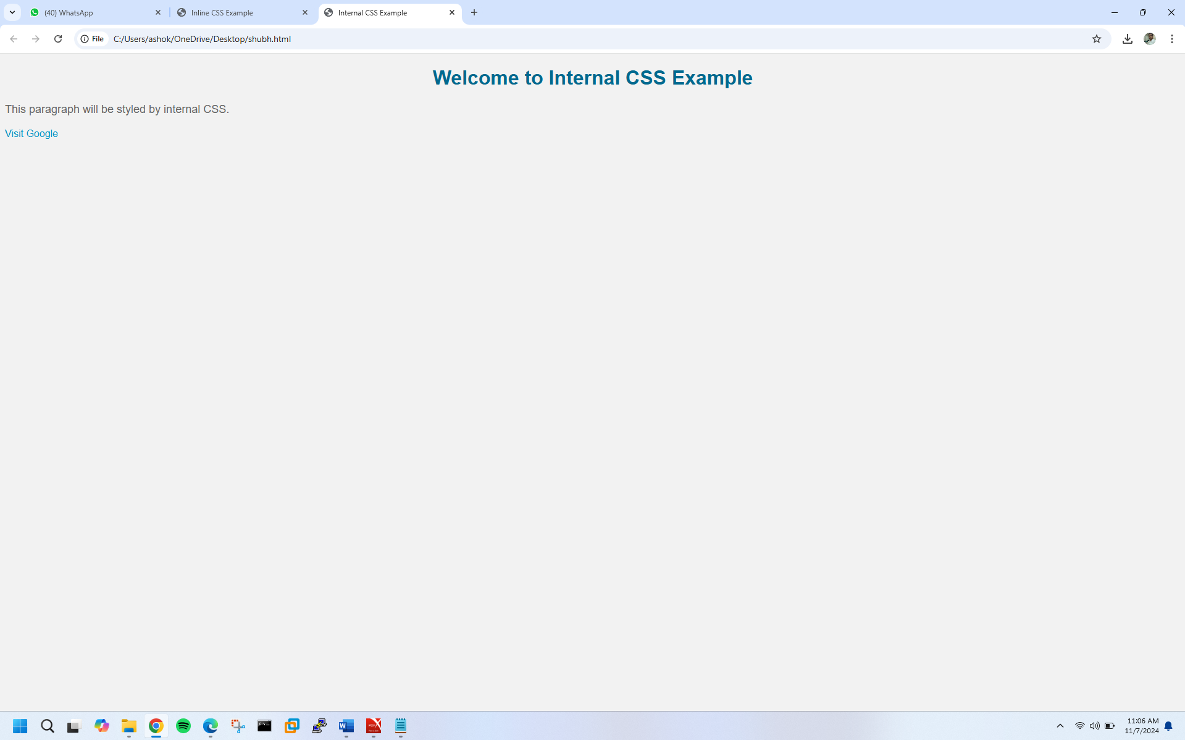

**EXERCISE N0.26**

Write code to show Inline CSS with HTML code.

<!DOCTYPE html>

<html>

<head>

<title>Inline CSS Example</title>

</head>

<body>

<!-- Inline CSS for h1 -->

<h1 style="color: #00698f; text-align: center;">Welcome to Inline CSS Example</h1>

<!-- Inline CSS for paragraph -->

<p style="font-size: 18px; color: #666; margin-bottom: 20px;">This paragraph will be styled by inline CSS.</p>

<!-- Inline CSS for link -->

<a href="(link unavailable)" style="text-decoration: none; color: #0096c7;">Visit Google</a>

<!-- Inline CSS for div -->

<div style="background-color: #f2f2f2; padding: 20px; border: 1px solid #ccc;">

<h2 style="color: #333;">Inline CSS Div</h2>

<p style="font-size: 16px;">This div will be styled by inline CSS.</p>

</div>

</body>

</html>

